Protective Relays
A protective relay is a device that detects the fault and initiates the operation of the circuit breaker
to ioslate the defective element from the rest of the system.
The relays detect the abnormal conditions in the electrical circuits by constantly measuring the
electrical quantities which are different under normal and fault conditions. The electrical quantities
which may change under fault conditions are voltage, current, frequency and phase angle. Through
the changes in one or more of these quantities, the faults signal their presence, type and location to the
protective relays. Having detected the fault, the relay operates to close the trip circuit of the breaker.
This results in the opening of the breaker and disconnection of the faulty circuit.

Fundamental Requirements of Protective Relaying
The principal function of protective relaying is to cause the prompt removal from service of any
element of the power system when it starts to operate in an abnormal manner or interfere with the
effective operation of the rest of the system. In order that protective relay system may perform this
function satisfactorily, it should have the following qualities :
(i) selectivity (ii) speed (iii) sensitivity
(iv) reliability (v) simplicity (vi) economy

(i) Selectivity. It is the ability of the protective system to select correctly that part of the system
in trouble and disconnect the faulty part without disturbing the rest of the system.
(ii) Speed. The relay system should disconnect the faulty section as fast as possible for the
following reasons :
(a) Electrical apparatus may be damaged if they are made to carry the fault currents for a long
time.
(b) A failure on the system leads to a great reduction in the system voltage. If the faulty section
is not disconnected quickly, then the low voltage created by the fault may shut down consumers’
motors and the generators on the system may become unstable.
(c) The high speed relay system decreases the possibility of development of one type of fault
into the other more severe type.

(iii) Sensitivity. It is the ability of the relay system to operate with low value of actuating
quantity.
Sensitivity of a relay is a function of the volt-amperes input to the coil of the relay necessary to
cause its operation. The smaller the volt-ampere input required to cause relay operation, the more
sensitive is the relay. Thus, a 1 VA relay is more sensitive than a 3 VA relay. It is desirable that relay
system should be sensitive so that it operates with low values of volt-ampere input.
(iv) Reliability. It is the ability of the relay system to operate under the pre-determined conditions.
Without reliability, the protection would be rendered largely ineffective and could even become
a liability.

(v) Simplicity. The relaying system should be simple so that it can be easily maintained. Reliability
is closely related to simplicity. The simpler the protection scheme, the greater will be its
reliability.

(vi) Economy. The most important factor in the choice of a particular protection scheme is the
economic aspect. Sometimes it is economically unjustified to use an ideal scheme of protection and
a compromise method has to be adopted. As a rule, the protective gear should not cost more than 5%
of total cost. However, when the apparatus to be protected is of utmost importance (e.g. generator,
main transmission line etc.), economic considerations are often subordinated to reliability.
- Basic Relays
Most of the relays used in the power system operate by virtue of the current and/or voltage supplied
by current and voltage transformers connected in various combinations to the system element that is
to be protected. Through the individual or relative changes in these two quantities, faults signal their
presence, type and location to the protective relays. Having detected the fault, the relay operates the
trip circuit which results in the opening of the circuit breaker and hence in the disconnection of the
faulty circuit.
Most of the relays in service on electric power system today are of electro-mechanical type.
They work on the following two main operating principles :
(i) Electromagnetic attraction
(ii) Electromagnetic induction
Electromagnetic Attraction Relays

Electromagnetic attraction relays operate by virtue of an armature being attracted to the poles of an
electromagnet or a plunger being drawn into a solenoid. Such relays may be actuated by d.c. or a.c.
quantities. The important types of electromagnetic attraction relays are :
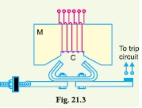
(i) Attracted armature type relay. Fig. 21.3 shows the
schematic arrangement of an attracted armature type relay. It
consists of a laminated electromagnet M carrying a coil C and
a pivoted laminated armature. The armature is balanced by a
counterweight and carries a pair of spring contact fingers at its
free end. Under normal operating conditions, the current
through the relay coil C is such that counterweight holds the
armature in the position shown. However, when a short-circuit
occurs, the current through the relay coil increases sufficiently
and the relay armature is attracted upwards. The contacts
on the relay armature bridge a pair of stationary contacts attached to the relay frame. This
completes the trip circuit which results in the opening of the circuit breaker and, therefore, in the
disconnection of the faulty circuit.
The minimum current at which the relay armature is attracted to close the trip circuit is called
pickup current. It is a usual practice to provide a number of tappings on the relay coil so that the
number of turns in use and hence the setting value at which the relay operates can be varied.
(ii) Solenoid type relay. Fig. 21.4 shows the schematic arrangement of a solenoid type relay. It
consists of a solenoid and movable iron plunger arranged as shown. Under normal operating conditions,
the current through the relay coil C is such that it holds the plunger by gravity or spring in the
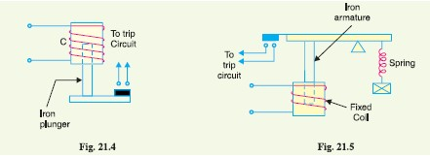
position shown. However, on the occurrence of a fault, the current through the relay coil becomes

more than the pickup value, causing the plunger to be attracted to the solenoid. The upward movement of the plunger closes the trip circuit, thus opening the circuit breaker and disconnecting the faulty circuit.
(iii) Balanced beam type relay. It consists of an iron armature fastened to a balance beam. Under normal operating conditions,the current through the relay coil is such that the beamis held in the horizontal position by the spring. However, when a fault occurs, the current through the relay coil becomes greater than the pickup value and the beam is attracted to close the trip circuit. This causes the opening of the circuit breaker to isolate the faulty circuit.
Induction Relays
The following three types of structures are commonly used for obtaining the phase difference in
the fluxes and hence the operating torque in induction relays :
(i) shaded-pole structure
(ii) watthour-meter or double winding structure
(iii) induction cup structure
(i) Shaded-pole structure. The general arrangement of shaded-pole structure is shown in Fig.
21.7. It consists of a pivoted aluminium disc free to rotate in the air-gap of an electromagnet. Onehalf
of each pole of the magnet is surrounded by a copper band known as shading ring. The alternating
flux ⎞s in the shaded protion of the poles will, owing to the reaction of the current induced in the
ring, lag behind the flux ⎞u in the unshaded portion by an angle ⟨. These two a.c. fluxes differing in
phase will produce the necessary torque to rotate the disc.
This shows that driving torque is proportional to the square of current in the relay coil.
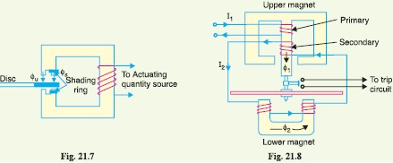
∝

(ii) Watthour-meter structure. This structure gets its name from the fact that it is used in watthour
meters. The general arrangement of this type of relay is shown in Fig. 21.8. It consists of a
pivoted aluminium disc arranged to rotate freely between the poles of two electromagnets. The upper
electromagnet carries two windings ; the pirmary and the secondary. The primary winding carries the
relay current I1 while the secondary winding is connected to the winding of the lower magnet. The
primary current induces e.m.f. in the secondary and so circulates a current I2 in it. The fluxϕ2 induced
in the lower magnet by the current in the secondary winding of the upper magnet will lag behind ϕ1 by
an angle α.The two fluxes ϕ1and ϕ2 differing in phase by ⟨ will produce a driving torque on the disc
proportional to ϕ1ϕ2 sin α
An important feature of this type of relay is that its operation can be controlled by opening or
closing the secondary winding circuit. If this circuit is opened, no flux can be set by the lower magnet
however great the vaule of current in the pirmary winding may be and consequently no torque will be
produced. Therefore, the relay can be made inoperative by opening its secondary winding circuit.
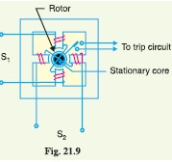
(iii) Induction cup structure. Fig. 21.9 shows the general arrangement of an induction cup structure. It most closely resembles an induction motor, except that the rotor iron is stationary, only the rotor conductor portion being free to rotate. The moving element is a hollow cylindrical rotor which turns on its axis. The rotating field is produced by two pairs of coils wound on four poles as shown. The rotating field induces currents in the cup to provide the necessary driving torque. If ϕ 1 and ϕ 2 represent the fluxes produced by the respective pairs of

poles,then torque produced is proportional to ϕ 1 ϕ 2 sin α
where α is the phase difference between the two fluxes.
A control spring and the back stop for closing of the contactscarried
on an arm are attached to the spindle of the cup to prevent the continuous rotation.
Induction cup structures are more efficient torque producers than either
the shaded-pole or the watthour meter structures. Therefore, this type of relay has
very high speed and may have an operatingtime less then 0·1 second.

Important Terms
It is desirable to define and explain some important terms much used in connection with relays.
(i) Pick-up current. It is the minimum current in the relay coil at which the relay starts to
operate. So long as the current in the relay is less than the pick-up value, the relay does not operate
and the breaker controlled by it remains in the closed position. However, when the relay coil current
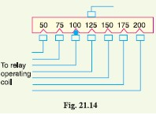
is equal to or greater than the pickup value, the relay
operates to energise the trip coil which opens the circuit
breaker.
(ii) Current setting. It is often desirable to adjust
the pick-up current to any required value. This is
known as current setting and is usually achieved by the
use of tappings on the relay operating coil. The taps
are brought out to a plug bridge as shown in Fig. 21.14.
The plug bridge permits to alter the number of turns on
the relay coil. This changes the torque on the disc and
hence the time of operation of the relay. The values
assigned to each tap are expressed in terms of percentage full-load rating of C.T. with which the relay
is associated and represents the value above which the disc commences to rotate and finally closes the
trip circuit.
∴ Pick-up current = Rated secondary current of C.T. ⋅ Current setting
For example, suppose that an overcurrent relay having current setting of 125% is connected to a
supply circuit through a current transformer of 400/5. The rated secondary current of C.T. is 5
amperes. Therefore, the pick-up value will be 25% more than 5 A i.e. 5 ⋅ 1·25 = 6·25 A. It means
that with above current setting, the relay will actually operate for a relay coil current equal to or
greater than 6·25 A.
The current plug settings usually range from 50% to 200% in steps of 25% for overcurrent relays
and 10% to 70% in steps of 10% for earth leakage relays. The desired current setting is obtained by
inserting a plug between the jaws of a bridge type socket at the tap value required.
(iii) Plug-setting multiplier (P.S.M.). It is the ratio of fault current in relay coil to the pick-up
current i.e.
P.S.M. =Fault current in relay coil/Pick - up current
=Fault current in relay coil /(Rated secondary current of CT ∗Current setting)
(iv) Time-setting multiplier. A relay is generally provided with
control to adjust the time of operation. This adjustment is known as
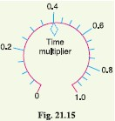
time-setting multiplier. The time-setting dial is calibrated from 0 to 1 in
steps of 0.05 sec (see Fig. 21.15). These figures are multipliers to be
used to convert the time derived from time/P.S.M. curve into the actual
operating time. Thus if the time setting is 0·1 and the time obtained
from the time/P.S.M. curve is 3 seconds, then actual relay operating
time = 3 ⋅ 0·1 = 0·3 second. For instance, in an induction relay, the time
of operation is controlled by adjusting the amount of travel of the disc
from its reset position to its pickup position. This is achieved by the adjustment of the position of a
movable backstop which controls the travel of the disc and thereby varies the time in which the relay
will close its contacts for given values of fault current. A so-called “time dial” with an evenly divided
scale provides this adjustment. The acutal time of operation is calculated by multiplying the time
setting multiplier with the time obtained from time/P.S.M. curve of the relay.

Functional Relay Types
Most of the relays in service on power system today operate on the principle of electromagnetic
attraction or electromagnetic induction. Regardless of the principle involved, relays are generally
classified according to the function they are called upon to perform in the protection of elelctric
power circuits. For example, a relay which recognises overcurrent in a circuit (i.e. current greater
than that which can be tolerated) and initiates corrective measures would be termed as an overcurrent
relay irrespective of the relay design. Similarly an overvoltage relay is one which recognises overvoltage
in a circuit and initiates the corrective measures. Although there are several types of specialfunction
relays, only the following important types will be discussed in this chapter :
(i) Induction type overcurrent relays
(ii) Induction type reverse power relays
(iii) Distance relays
(iv) Differential relays
(v) Translay scheme
Induction Type Overcurrent Relay (non-directional)
This type of relay works on the induction principle and initiates corrective measures when current in
the circuit exceeds the predetermined value. The actuating source is a current in the circuit supplied
to the relay from a current transformer. These relays are used on a.c. circuits only and can operate for
fault current flow in either direction.
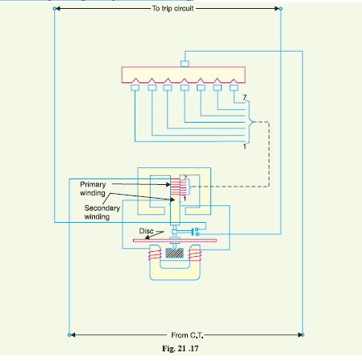

Constructional details. Fig. 21.17 shows the important constructional details of a typical nondirectional
induction type overcurrent relay. It consists of a metallic (aluminium) disc which is free to
rotate inbetween the poles of two electromagnets. The upper electromagnet has a primary and a
secondary winding. The primary is connected to the secondary of a C.T. in the line to be protected
and is tapped at intervals. The tappings are connected to a plug-setting bridge by which the number
of active turns on the relay operating coil can be varied, thereby giving the desired current setting.
The secondary winding is energised by induction from primary and is connected in series with the
winding on the lower magnet. The controlling torque is provided by a spiral spring.
The spindle of the disc carries a moving contact which bridges two fixed contacts (connected to
trip circuit) when the disc rotates through a pre-set angle. This angle can be adjusted to any value
between 0o and 360o. By adjusting this angle, the travel of the moving contact can be adjusted and
hence the relay can be given any desired time setting.
Operation. The driving torque on the aluminium disc is set up due to the induction principle as
discussed in Art. 21.5. This torque is opposed by the restraining torque provided by the spring.
Under normal operating conditions, restraining torque is greater than the driving torque produced by
the relay coil current. Therefore, the aluminium disc remains stationary. However, if the current in
the protected circuit exceeds the pre-set value, the driving torque becomes greater than the restraining
torque. Consequently, the disc rotates and the moving contact bridges the fixed contacts when the
disc has rotated through a pre-set angle. The trip circuit operates the circuit breaker which isolates
the faulty section.
Induction Type Directional Power Relay
This type of relay operates when power in the circuit flows in a specific direction. Unlike a *nondirectional
overcurrent relay, a directional power relay is so designed that it obtains its operating
torque by the interaction of magnetic fields derived from both voltage and current source of the
circuit it protects. Thus this type of relay is essentially a wattmeter and the direction of the torque set
up in the relay depends upon the direction of the current relative to the voltage with which it is
associated.
Constructional details. Fig. 21.18 shows the essential parts of a typical induction type directional
power relay. It consists of an aluminum disc which is free to rotate inbetween the poles of two
electromagnets. The upper electromagnet carries a winding (called potential coil) on the central limb
which is connected through a potential transformer (P.T.) to the circuit voltage source. The lower
electromagnet has a separate winding (called current coil) connected to the secondary of C.T. in the
line to be protected. The current coil is provided with a number of tappings connected to the plugsetting
bridge (not shown for clarity). This permits to have any desired current setting. The restraining
torque is provided by a spiral spring. The spindle of the disc carries a moving contact which bridges two fixed contacts when the disc
has rotated through a pre-set angle. By adjusting this angle, the travel of the moving disc can be
adjusted and hence any desired time-setting can be given to the relay.
Operation. The flux ϕ1 due to current in the potential coil will be nearly 90º lagging behind the
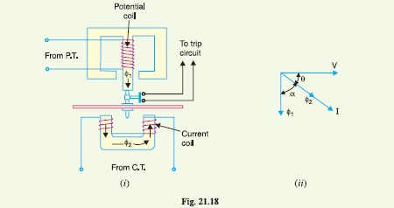
applied voltage V. The flux ϕ2 due to current coil will be nearly in phase with the operating current I

It is clear that the direction of driving torque on the disc depends upon the direction of power
flow in the circuit to which the relay is associated. When the power in the circuit flows in the normal
direction, the driving torque and the restraining torque (due to spring) help each other to turn away
the moving contact from the fixed contacts. Consequently, the relay remains inoperative. However,
the reversal of current in the circuit reverses the direction of driving torque on the disc. When the
reversed driving torque is large enough, the disc rotates in the reverse direction and the moving
contact closes the trip circuit. This causes the operation of the circuit breaker which disconnects the
faulty section.
Induction Type Directional Overcurrent Relay
The directional power relay discussed above is unsuitable for use as a directional protective relay
under short-circuit conditions. When a short-circuit occurs, the system voltage falls to a low value
and there may be *insufficient torque developed in the relay to cause its operation. This difficulty is
overcome in the directional overcurrent relay which is designed to be almost independent of system
voltage and power factor

Constructional details. Fig. 21.19 shows the constructional details of a typical induction type
directional ovecurrent relay. It consists of two relay elements mounted on a common case viz. (i)
directional element and (ii) non-directional element.

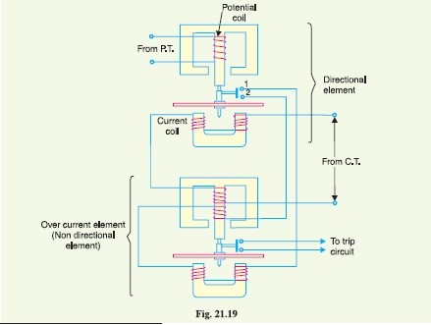

(i) Directional element. It is essentially a directional power relay which operates when power
flows in a specific direction. The potential coil of this element is connected through a potential
transformer (P.T.) to the system voltage. The current coil of the element is energised through a C.T.
by the circuit current. This winding is carried over the upper magnet of the non-directional element.
The trip contacts (1 and 2) of the directional element are connected in series with the secondary
circuit of the overcurrent element. Therefore, the latter element cannot start to operate until its
secondary circuit is completed. In other words, the directional element must operate first (i.e. contacts
1 and 2 should close) in order to operate the overcurrent element.
(ii) Non-directional element. It is an overcurrent element similar in all respects to a non-directional
overcurrent relay described in Art. 21.11. The spindle of the disc of this element carries a
moving contact which closes the fixed contacts (trip circuit contacts) after the operation of directional
element.
It may be noted that plug-setting bridge is also provided in the relay for current setting but has
been omitted in the figure for clarity and simplicity. The tappings are provided on the upper magnet
of overcurrent element and are connected to the bridge.
Operation. Under normal operating conditions, power flows in the normal direction in the
circuit protected by the relay. Therefore, directional power relay (upper element) does not operate,
thereby keeping the overcurrent element (lower element) unenergised. However, when a short-circuit
occurs, there is a tendency for the current or power to flow in the reverse direction. Should this
happen, the disc of the *upper element rotates to bridge the fixed contacts 1 and 2. This completes
the circuit for overcurrent element. The disc of this element rotates and the moving contact attached
to it closes the trip circuit. This operates the circuit breaker which isolates the faulty section. The two
relay elements are so arranged that final tripping of the current controlled by them is not made till the
following conditions are satisfied :
(i) current flows in a direction such as to operate the directional element.
(ii) current in the reverse direction exceeds the pre-set value.
(iii) excessive current persists for a period corresponding to the time setting of overcurrent element.

Differential Relays
Most of the relays discussed so far relied on excess of current for their operation. Such relays are less
sensitive because they cannot make correct distinction between heavy load conditions and minor
fault conditions. In order to overcome this difficulty, differential relays are used.
differential relay is one that operates when the phasor difference of two or more similar
electrical quantities exceeds a pre-determined value.
Thus a current differential relay is one that compares the current entering a section of the system
with the current leaving the section. Under normal operating conditions, the two currents are equal
but as soon as a fault occurs, this condition no longer applies. The difference between the incoming
and outgoing currents is arranged to flow through the operating coil of the relay. If this differential
current is equal to or greater than the pickup value, the relay will operate and open the circuit breaker
to isolate the faulty section.
It may be noted that almost any type of relay when connected in a particular way can be made to
operate as a differential relay. In other words, it is not so much the relay construction as the way the
relay is connected in a circuit that makes it a differential relay. There are two fundamental systems of
differential or balanced protection viz.
- Current balance protection (ii) Voltage balance protection
Current Differential Relay
Fig. 21.23 shows an arrangement of an overcurrent relay connected to operate as a differential relay.
A pair of identical current transformers are fitted on either end of the section to be protected (alternator
winding in this case). The secondaries of CT’s are connected in series in such a way that they
carry the induced currents in the same direction. The operating coil of the overcurrent relay is connected
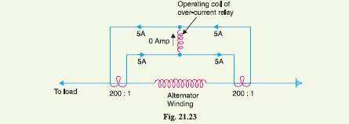
across the CT secondary circuit. This differential relay compares the current at the two ends of the alternator winding.

Under normal operating conditions, suppose the alternator winding carries a normal current of
1000 A. Then the currents in the two secondaries of CT’s are equal [See Fig. 21.23]. These currents
will merely circulate between the two CT’s and no current will flow through the differential relay.
Therefore, the relay remains inoperative. If a ground fault occurs on the alternator winding as shown
in Fig. 21.24 (i), the two secondary currents will not be equal and the current flows through the
operating coil of the relay, causing the relay to operate. The amount of current flow through the relay
will depend upon the way the fault is being fed.
(i) If some current (500 A in this case) flows out of one side while a larger current (2000 A)
enters the other side as shown in Fig. 21.24 (i), then the difference of the CT secondary
currents i.e. 10 − 2·5 = 7·5 A will flow through the relay.
(ii) If current flows to the fault from both sides as shown in Fig. 21.24 (ii), then sum of CT
secondary currents i.e. 10 + 5 = 15 A will flow through the relay.

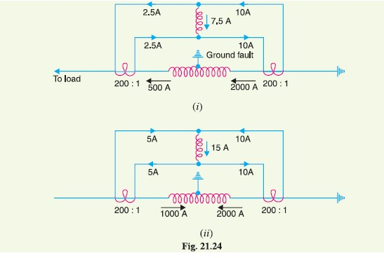

Disadvantages
(i) The impedance of the *pilot cables generally causes a slight difference between the currents
at the two ends of the section to be protected. If the relay is very sensitive, then the small
differential current flowing through the relay may cause it to operate even under no fault
conditions.
(ii) Pilot cable capacitance causes incorrect operation of the relay when a large through-current
flows.
(iii) Accurate matching of current transformers cannot be achieved due to pilot circuit impedance.
The above disadvantages are overcome to a great extent in biased beam relay.
Voltage Balance Differential Relay
Fig. 21.27 shows the arrangement of voltage balance protection. In this scheme of protection, two
similar current transformers are connected at either end of the element to be protected (e.g. an alternator
winding) by means of pilot wires. The secondaries of current transformers are connected in
series with a relay in such a way that under normal conditions, their induced e.m.f.s’ are in opposition.
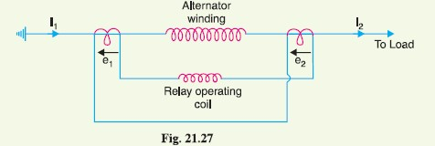

Under healthy conditions, equal currents (I1 = I2) flow in both primary windings. Therefore, the
secondary voltages of the two transformers are balanced against each other and no current will flow
through the relay operating coil. When a fault occurs in the protected zone, the currents in the two
primaries will differ from one another (i.e. I1 not equals to I2) and their secondary voltages will no longer be in
balance. This voltage †difference will cause a current to flow through the operating coil of the relay
which closes the trip circuit.
Disadvantages
The voltage balance system suffers from the following drawbacks :
(i) A multi-gap transformer construction is required to achieve the accurate balance between
current transformer pairs.
(ii) The system is suitable for protection of cables of relatively short lengths due to the capacitance
of pilot wires. On long cables, the charging current may be sufficient to operate the
relay even if a perfect balance of current transformers is attained.
The above disadvantages have been overcome in Translay (modified) balanced voltage system.
Types of Protection
When a fault occurs on any part of electric power system, it must be cleared quickly in order to avoid
damage and/or interference with the rest of the system. It is a usual practice to divide the protection
scheme into two classes viz. primary protection and back-up protection.
(i) Primary Protection. It is the protection scheme which is designed to protect the component
parts of the power system. Thus referring to Fig. 21.29, each line has an overcurrent
relay that protects the line. If a fault occurs on any line, it will be cleared by its relay and
circuit breaker. This forms the primary or main protection and serves as the first line of
defence. The service record of primary relaying is very high with well over ninety percent
of all operations being correct. However, sometimes faults are not cleared by primary relay
system because of trouble within the relay, wiring system or breaker. Under such conditions,
back-up protection does the required job.
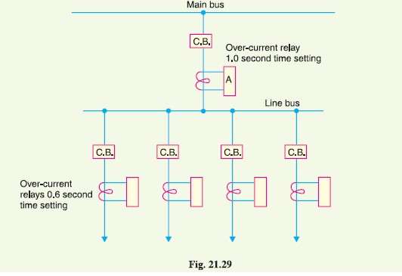

(ii) Back-up protection. It is the second line of defence in case of failure of the primary protection.
It is designed to operate with sufficient time delay so that primary relaying will be
given enough time to function if it is able to. Thus referring to Fig. 21.29, relay A provides
back-up protection for each of the four lines. If a line fault is not cleared by its relay and
breaker, the relay A on the group breaker will operate after a definite time delay and clear the
entire group of lines. It is evident that when back-up relaying functions, a larger part is
disconnected than when primary relaying functions correctly. Therefore, greater emphasis
should be placed on the better maintenance of primary relaying.

