Voltage Surge
A sudden rise in voltage for a very short duration on the power system is known as a voltage surge or transient voltage.
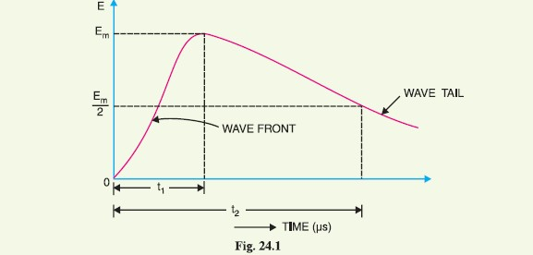
Transients or surges are of temporary nature and exist for a very short duration (a few hundred μs) but they cause overvoltages on the power system. They originate from switching and from other causes but by far the most important transients are those caused by lightning striking a transmissionline. When lightning strikes a line, the surge rushes along the line, just as a flood of water rushes along a narrow valley when the retaining wall of a reservoir at its head suddenly gives way. In most of the cases, such surges may cause the line insulators (near the point where lightning has struck) to flash over and may also damage the nearby transformers, generators or other equipment connected to the line if the equipment is not suitably protected.

Fig. 24.1 shows the wave-form of a typical lightning surge. The voltage build-up is taken along
y-axis and the time along x-axis. It may be seen that lightning introduces a steep-fronted wave. The
steeper the wave front, the more rapid is the build-up of voltage at any point in the network. In most
of the cases, this build-up is comparatively rapid, being of the order of 1–5μs. Voltage surges are
generally specified in terms of *rise time t1 and the time t2 to decay to half of the peak value. For
example, a 1/50 μs surge is one which reaches its maximum value in 1μs and decays to half of its peak
value is 50 μs.
Causes of Overvoltages
The overvoltages on a power system may be broadly divided into two main categories viz.
1. Internal causes
(i) Switching surges (ii) Insulation failure
(iii) Arcing ground (iv) Resonance
2. External causes i.e. lightning
Internal causes do not produce surges of large magnitude. Experience shows that surges due to
internal causes hardly increase the system voltage to twice the normal value. Generally, surges due to
internal causes are taken care of by providing proper insulation to the equipment in the power system.
However, surges due to lightning are very severe and may increase the system voltage to several times
the normal value. If the equipment in the power system is not protected against lightning surges,
these surges may cause considerable damage. In fact, in a power system, the protective devices
provided against overvoltages mainly take care of lightning surges.
Internal Causes of Overvoltages
Internal causes of overvoltages on the power system are primarily due to oscillations set up by the
sudden changes in the circuit conditions. This circuit change may be a normal switching operation
such as opening of a circuit breaker, or it may be the fault condition such as grounding of a line
conductor. In practice, the normal system insulation is suitably designed to withstand such surges.
We shall briefly discuss the internal causes of overvoltages.
1. Switching Surges. The overvoltages produced on the power system due to switching
operations are known as switching surges. A few cases will be discussed by way of illustration :
(i) Case of an open line. During switching operations of an unloaded line, travelling waves are
set up which produce overvoltages on the line. As an illustration, consider an unloaded line being
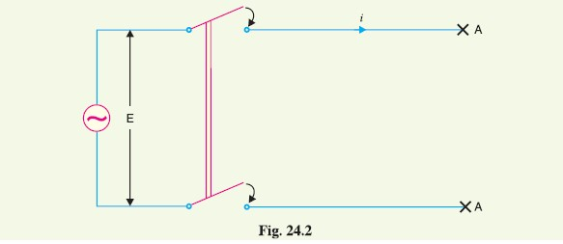
connected to a voltage source as shown in Fig. 24.2.

When the unloaded line is connected to the voltage source, a voltage wave is set up which travels
along the line. On reaching the terminal point A, it is reflected back to the supply end without change
of sign. This causes voltage doubling i.e. voltage on the line becomes twice the normal value. If
Er.m.s. is the supply voltage, then instantaneous voltage which the line will have to withstand will be
2 √2 E . This overvoltage is of temporary nature. It is because the line losses attenuate the wave and
in a very short time, the line settles down to its normal supply voltage E. Similarly, if an unloaded line
is switched off, the line will attain a voltage of 2√2 E for a moment before settling down to the
normal value.
(ii) Case of a loaded line. Overvoltages will also be produced during the switching operations
of a loaded line. Suppose a loaded line is suddenly interrupted. This will set up a voltage of 2 Zn i
across the break (i.e. switch) where i is the instantaneous value of current at the time of opening of
line and *Zn is the natural impedance of the line. For example, suppose the line having Zn = 1000 Ωcarries a current of 100 A (r.m.s.) and the break occurs at the moment when current is maximum. The
voltage across the breaker (i.e. switch) = 2 √2 ∗100 ∗ 1000/1000 = 282·8 kV. If Vm is the peak value
of voltage in kV, the maximum voltage to which the line may be subjected is = (Vm + 282·8) kV.
(iii) Current chopping. Current chopping results in the production of high voltage transients
across the contacts of the air blast circuit breaker as detailed in chapter 19. It is briefly discussed
here. Unlike oil circuit breakers, which are independent for the effectiveness on the magnitude of the current being interrupted, air-blast circuit breakers retain the same extinguishing power irrespective
of the magnitude of this current. When breaking low currents (e.g. transformer magnetising current)
with air-blast breaker, the powerful de-ionising effect of air-blast causes the current to fall abruptly to
zero well before the natural current zero is reached. This phenomenon is called current chopping and
produces high transient voltage across the breaker contacts. Overvoltages due to current chopping
are prevented by resistance switching (See Chapter 19).
2. Insulation failure. The most common case of insulation failure in a power system is the
grounding of conductor (i.e. insulation failure between line and earth) which may cause overvoltages
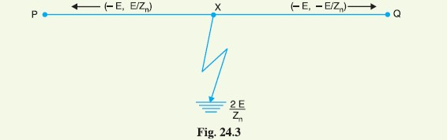
in the system. This is illustrated in Fig. 24.3.

Suppose a line at potential E is earthed at point X. The earthing of the line causes two equal
voltages of −E to travel along XQ and XP containing currents −E/Zn and +E/Zn respectively. Both
these currents pass through X to earth so that current to earth is 2 E/Zn.
3. Arcing ground. In the early days of transmission, the neutral of three phase lines was not
earthed to gain two advantages. Firstly, in case of line-to-ground fault, the line is not put out of
action. Secondly, the zero sequence currents are eliminated, resulting in the decrease of interference
with communication lines. Insulated neutrals give no problem with short lines and comparatively low
voltages. However, when the lines are long and operate at high voltages, serious problem called
arcing ground is often witnessed. The arcing ground produces severe oscillations of three to four
times the normal voltage.
The phenomenon of intermittent arc taking place in line-to-ground fault of a 3 phase system with
consequent production of transients is known as arcing ground.
The transients produced due to arcing ground are cumulative and may cause serious damage to
the equipment in the power system by causing breakdown of insulation. Arcing ground can be prevented
by earthing the neutral.
4. Resonance. Resonance in an electrical system occurs when inductive reactance of the circuit
becomes equal to capacitive reactance. Under resonance, the impedance of the circuit is equal to
resistance of the circuit and the p.f. is unity. Resonance causes high voltages in the electrical system.
In the usual transmission lines, the capacitance is very small so that resonance rarely occurs at the
fundamental supply frequency. However, if generator e.m.f. wave is distorted, the trouble of resonance
may occur due to 5th or higher harmonics and in case of underground cables too.
24.4 Lightning
An electric discharge between cloud and earth, between clouds or between the charge centres of the
same cloud is known as lightning.
Lightning is a huge spark and takes place when clouds are charged to such a high potential (+ve
or −ve) with respect to earth or a neighbouring cloud that the dielectric strength of neighbouring
medium (air) is destroyed. There are several theories which exist to explain how the clouds acquire
charge. The most accepted one is that during the uprush of warm moist air from earth, the friction between the air and the tiny particles of water causes the building up of charges. When drops of water
are formed, the larger drops become positively charged and the smaller drops become negatively
charged. When the drops of water accumulate, they form clouds, and hence cloud may possess either
a positive or a negative charge, depending upon the charge of drops of water they contain. The charge
on a cloud may become so great that it may discharge to another cloud or to earth and we call this
discharge as lightning. The thunder which accompanies lightning is due to the fact that lightning
suddenly heats up the air, thereby causing it to expand. The surrounding air pushes the expanded air
back and forth causing the wave motion of air which we recognise as thunder.
Mechanism of Lightning Discharge
Let us now discuss the manner in which a lightning discharge occurs. When a charged cloud passes
over the earth, it induces equal and opposite charge on the earth below. Fig. 24.4 shows a negatively
charged cloud inducing a positive charge on the earth below it. As the charge acquired by the cloud
increases, the potential between cloud and earth increases and, therefore, gradient in the air increases.
When the potential gradient is sufficient (5 kV*/cm to 10 kV/cm) to break down the surrounding air,
the lightning stroke starts. The stroke mechanism is as under :
(i) As soon as the air near the cloud breaks down, a streamer called leader streamer or pilot
streamer starts from the cloud towards the earth and carries charge with it as shown in Fig.
24.4 (i). The leader streamer will continue its journey towards earth as long as the cloud,
from which it originates feeds enough charge to it to maintain gradient at the tip of leader
streamer above the strength of air. If this gradient is not maintained, the leader streamer
stops and the charge is dissipated without the formation of a complete stroke. In other
words, the leader streamer will not reach the earth. Fig. 24.4 (i) shows the leader streamer
being unable to reach the earth as gradient at its end cloud not be maintained above the
strength of air. It may be noted that current in the leader streamer is low (<100 A) and its
velocity of propagation is about 0·05% that of velocity of light. Moreover, the luminosity
of leader is also very low.
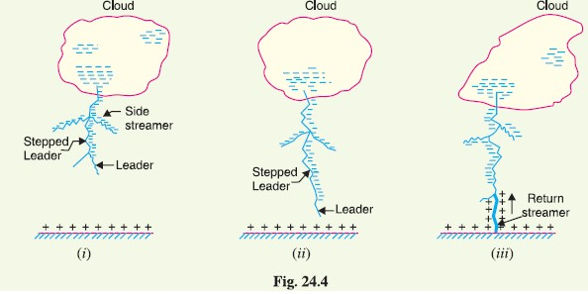

(ii) In many cases, the leader streamer continues its journey towards earth [See Fig. 24.4 (ii)]
until it makes contact with earth or some object on the earth. As the leader streamer moves
towards earth, it is accompanied by points of luminescence which travel in jumps giving rise to stepped leaders. The velocity of stepped leader exceeds one-sixth of that of light
and distance travelled in one step is about 50 m. It may be noted that stepped leaders have
sufficient luminosity and give rise to first visual phenomenon of discharge.
(iii) The path of leader streamer is a path of ionisation and, therefore, of complete breakdown
of insulation. As the leader streamer reaches near the earth, a return streamer shoots up
from the earth [See Fig. 24.4 (iii)] to the cloud, following the same path as the main channel
of the downward leader. The action can be compared with the closing of a switch between
the positive and negative terminals; the downward leader having negative charge and return
streamer the positive charge. This phenomenon causes a sudden spark which we call
lightning. With the resulting neutralisation of much of the negative charge on the cloud,
any further discharge from the cloud may have to originate from some other portion of it.
The following points may be noted about lightning discharge :
(a) A lightning discharge which usually appears to the eye as a single flash is in reality made up
of a number of separate strokes that travel down the same path. The interval between them
varies from 0·0005 to 0·5 second. Each separate stroke starts as a downward leader from
the cloud.
(b) It has been found that 87% of all lightning strokes result from negatively charged clouds
and only 13% originate from positively charged clouds.
(c) It has been estimated that throughout the world, there occur about 100 lightning strokes per
second.
(d) Lightning discharge may have currents in the range of 10 kA to 90 kA.
24.6 Types of Lightning Strokes
There are two main ways in which a lightning may strike the power system (e.g. overhead lines,
towers, sub-stations etc.), namely;
1. Direct stroke 2. Indirect stroke
1. Direct stroke. In the direct stroke, the lightning discharge (i.e. current path) is directly from
the cloud to the subject equipment e.g. an overhead line. From the line, the current path may be over
the insulators down the pole to the ground. The overvoltages set up due to the stroke may be large
enough to flashover this path directly to the ground. The direct strokes can be of two types viz.
(i) Stroke A and (ii) stroke B.

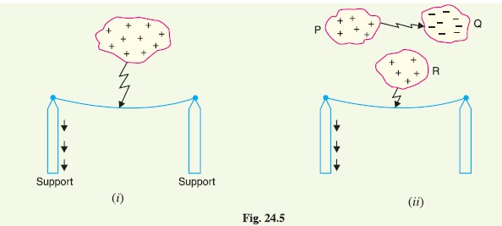

(i) In stroke A, the lightning discharge is from the cloud to the subject equipment i.e. an overhead
line in this case as shown in Fig. 24.5 (i). The cloud will induce a charge of opposite sign on the tall object (e.g. an overhead line in this case). When the potential between the
cloud and line exceeds the breakdown value of air, the lightning discharge occurs between
the cloud and the line.
(ii) In stroke B, the lightning discharge occurs on the overhead line as a result of stroke A
between the clouds as shown in Fig. 24.5 (ii). There are three clouds P, Q and R having
positive, negative and positive charges respectively. The charge on the cloud Q is bound
by the cloud R. If the cloud P shifts too near the cloud Q, then lightning discharge will
occur between them and charges on both these clouds disappear quickly. The result is that
charge on cloud R suddenly becomes free and it then discharges rapidly to earth, ignoring
tall objects.
Two points are worth noting about direct strokes. Firstly, direct strokes on the power system are
very rare. Secondly, stroke A will always occur on tall objects and hence protection can be provided
against it. However, stroke B completely ignores the height of the object and can even strike the
ground. Therefore, it is not possible to provide protection against stroke B.
2. Indirect stroke. Indirect strokes result from the electrostatically induced charges on the
conductors due to the presence of charged clouds. This is illustrated in Fig. 24.6. A positively
charged cloud is above the line and induces a negative charge on the line by electrostatic induction.
This negative charge, however, will be only on that portion of the line right under the cloud and the
portions of the line away from it will be positively charged as shown in Fig. 24.6. The induced
positive charge leaks slowly to earth via the insulators. When the cloud discharges to earth or to
another cloud, the negative charge on the wire is isolated as it cannot flow quickly to earth over the
insulators. The result is that negative charge rushes along the line is both directions in the form of
travelling waves. It may be worthwhile to mention here that majority of the surges in a transmission
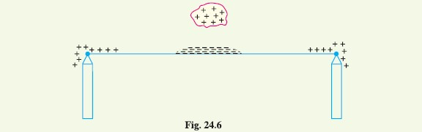
line are caused by indirect lightning strokes.

Harmful Effects of Lightning
A direct or indirect lightning stroke on a transmission line produces a steep-fronted voltage wave on
the line. The voltage of this wave may rise from zero to peak value (perhaps 2000 kV) in about 1 μs
and decay to half the peak value in about 5μs. Such a steep-fronted voltage wave will initiate travelling
waves along the line in both directions with the velocity dependent upon the L and C parameters
of the line.
(i) The travelling waves produced due to lightning surges will shatter the insulators and may
even wreck poles.
(ii) If the travelling waves produced due to lightning hit the windings of a transformer or generator,
it may cause considerable damage. The inductance of the windings opposes any
sudden passage of electric charge through it. Therefore, the electric charges “piles up”
against the transformer (or generator). This induces such an excessive pressure between
the windings that insulation may breakdown, resulting in the production of arc. While the
normal voltage between the turns is never enough to start an arc, once the insulation has broken down and an arc has been started by a momentary overvoltage, the line voltage is
usually sufficient to maintain the arc long enough to severely damage the machine.
(iii) If the arc is initiated in any part of the power system by the lightning stroke, this arc will set
up very disturbing oscillations in the line. This may damage other equipment connected to
the line.
Lightning Arresters
The earthing screen and ground wires can well protect the electrical system against direct lightning
strokes but they fail to provide protection against travelling waves which may reach the terminal
apparatus. The lightning arresters or surge diverters provide protection against such surges.
A lightning arrester or a surge diverter is a protective device which conducts the high voltage
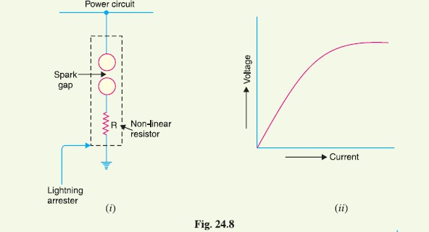
surges on the power system to the ground.

Fig. 24.8 (i) shows the basic form of a surge diverter. It consists of a spark gap in series with a
non-linear resistor. One end of the diverter is connected to the terminal of the equipment to be
protected and the other end is effectively grounded. The length of the gap is so set that normal line
voltage is not enough to cause an arc across the gap but a dangerously high voltage will break down
the air insulation and form an arc. The property of the non-linear resistance is that its resistance
decreases as the voltage (or current) increases and vice-versa. This is clear from the *volt/amp
characteristic of the resistor shown in Fig. 24.8 (ii).
Action. The action of the lightning arrester or surge diverter is as under :
(i) Under normal operation, the lightning arrester is off the line i.e. it conducts **no current to
earth or the gap is non-conducting.
(ii) On the occurrence of overvoltage, the air insulation across the gap breaks down and an arc
is formed, providing a low resistance path for the surge to the ground. In this way, the
excess charge on the line due to the surge is harmlessly conducted through the arrester to
the ground instead of being sent back over the line.
(iii) It is worthwhile to mention the function of non-linear resistor in the operation of arrester.
As the gap sparks over due to overvoltage, the arc would be a short-circuit on the power
system and may cause power-follow current in the arrester. Since the characteristic of the
resistor is to offer high resistance to high voltage (or current), it prevents the effect of a
short-circuit. After the surge is over, the resistor offers high resistance to make the gap
non-conducting.
Two things must be taken care of in the design of a lightning arrester. Firstly, when the surge is
over, the arc in gap should cease. If the arc does not go out, the current would continue to flow
through the resistor and both resistor and gap may be destroyed. Secondly, I R drop (where I is the
surge current) across the arrester when carrying surge current should not exceed the breakdown strength
of the insulation of the equipment to be protected.
24.12 Types of Lightning Arresters
There are several types of lightning arresters in general use. They differ only in constructional details but operate on the same principle viz. providing low resistance path for the surges to the ground. We
shall discuss the following types of lightning arresters :
1. Rod gap arrester 2. Horn gap arrester
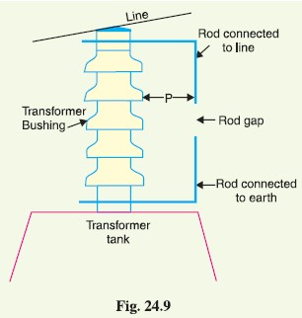
3. Multigap arrester 4. Expulsion type lightning arrester
5. Valve type lightning arrester
1. Rod Gap Arrester. It is a very simple
type of diverter and consists of two 1·5 cm rods
which are bent at right angles with a gap inbetween
as shown in Fig. 24.9. One rod is connected to
the line circuit and the other rod is connected to
earth. The distance between gap and insulator
(i.e. distance P) must not be less than one-third of
the gap length so that the arc may not reach the
insulator and damage it. Generally, the gap length
is so adjusted that breakdown should occur at 80%
of spark- over voltage in order to avoid cascading
of very steep wave fronts across the insulators.
The string of insulators for an overhead line
on the bushing of transformer has frequently a rod
gap across it. Fig. 24.9 shows the rod gap across
the bushing of a transformer.
Under normal operating conditions, the gap
remains non-conducting. On the occurrence of a high voltage surge on the line, the gap sparks over
and the surge current is conducted to earth. In this way, excess charge on the line due to the surge is
harmlessly conducted to earth.
Limitations
(i) After the surge is over, the arc in the gap is maintained by the †normal supply voltage,
leading to a short-circuit on the system.
(ii) The rods may melt or get damaged due to excessive heat produced by the arc.
(iii) The climatic conditions (e.g. rain, humidity, temperature etc.) affect the performance of
rod gap arrester.
(iv) The polarity of the surge also affects the performance of this arrester.
Due to the above limitations, the rod gap arrester is only used as a ‘back-up’ protection in case of
main arresters.
2. Horn Gap Arrester. Fig. 24.10 shows the horn gap arrester. It consists of two horn shaped
metal rods A and B separated by a small air gap. The horns are so constructed that distance between
them gradually increases towards the top as shown. The horns are mounted on porcelain insulators.
One end of horn is connected to the line through a resistance R and choke coil L while the other end
is effectively grounded. The resistance R helps in limiting the follow current to a small value. The
choke coil is so designed that it offers small reactance at normal power frequency but a very high
reactance at transient frequency. Thus the choke does not allow the transients to enter the apparatus
to be protected. The gap between the horns is so adjusted that normal supply voltage is not enough to
cause an arc across the gap.
Under normal conditions, the gap is non-conducting i.e. normal supply voltage is insufficient to
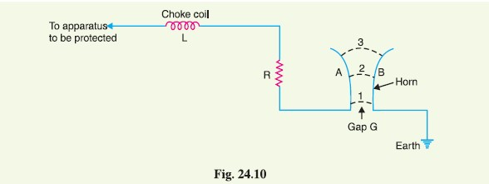
initiate the arc between the gap. On the occurrence of an overvoltage, spark-over takes place across

the *small gap G. The heated air around the arc and the magnetic effect of the arc cause the arc to
travel up the gap. The arc moves progressively into positions 1, 2 and 3. At some position of the arc
(perhaps position 3), the distance may be too great for the voltage to maintain the arc. Consequently,
the arc is extinguished. The excess charge on the line is thus conducted through the arrester to the
ground.
Advantages
(i) The arc is self-clearing. Therefore, this type of arrester does not cause short-circuiting of
the system after the surge is over as in the case of rod gap.
(ii) Series resistance helps in limiting the follow current to a small value.
Limitations
(i) The bridging of gap by some external agency (e.g. birds) can render the device useless.
(ii) The setting of horn gap is likely to change due to corrosion or pitting. This adversely
affects the performance of the arrester.
(iii) The time of operation is comparatively long, say about 3 seconds. In view of the very short
operating time of modern protective gear for feeders, this time is far long.
Due to the above limitations, this type of arrester is not reliable and can only be used as a second
line of defence like the rod gap arrester.
3. Multigap arrester. Fig. 24.11 shows the multigap arrester. It consists of a series of metallic
(generally alloy of zinc) cylinders insulated from one another and separated by small intervals of air
gaps. The first cylinder (i.e. A) in the series is connected to the line and the other to the ground
through a series resistance. The series resistance limits the power arc. By the inclusion of series
resistance, the degree of protection against travelling waves is reduced. In order to overcome this
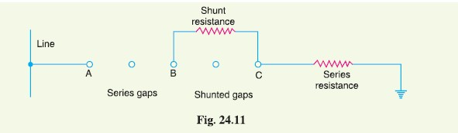
difficulty, some of the gaps (B to C in Fig. 24.11) are shunted by a resistance.

Under normal conditions, the point B is at earth potential and the normal supply voltage is unable
to break down the series gaps. On the occurrence of an overvoltage, the breakdown of series gaps A
to B occurs. The heavy current after breakdown will choose the straight - through path to earth via the
shunted gaps B and C, instead of the alternative path through the shunt resistance. When the surge is
over, the arcs B to C go out and any power current following the surge is limited by the two resistances
(shunt resistance and series resistance) which are now in series. The current is too small to maintain
the arcs in the gaps A to B and normal conditions are restored. Such arresters can be employed where
system voltage does not exceed 33 kV.
4. Expulsion type arrester. This type of arrester is also called ‘protector tube’ and is commonly
used on system operating at voltages upto 33 kV. Fig. 24.12 (i) shows the essential parts of an
expulsion type lightning arrester. It essentially consists of a rod gap A A′ in series with a second gap
enclosed within the fibre tube. The gap in the fibre tube is formed by two electrodes. The upper
electrode is connected to rod gap and the lower electrode to the earth. One expulsion arrester is
placed under each line conductor. Fig. 24.12 (ii) shows the installation of expulsion arrester on an
overhead line.
On the occurrence of an overvoltage on the line, the series gap A A′ is spanned and an arc is
struck between the electrodes in the tube. The heat of the arc vaporises some of the fibre of tube
walls, resulting in the production of a neutral gas*. In an extremely short time, the gas builds up high
pressure and is expelled through the lower electrode which is hollow. As the gas leaves the tube
violently, it carries away ionised air around the arc. This de-ionising effect is generally so strong that
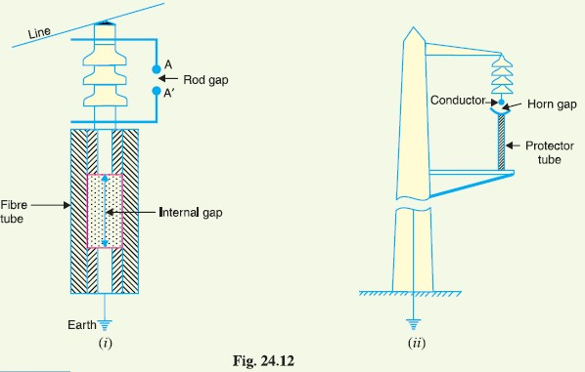
arc goes out at a current zero and will not be re-established.

Advantages
(i) They are not very expensive.
(ii) They are improved form of rod gap arresters as they block the flow of power frequency
follow currents.
(iii) They can be easily installed.

Limitations
(i) An expulsion type arrester can perform only limited number of operations as during each
operation some of the fibre material is used up.
(ii) This type of arrester cannot be mounted in an enclosed equipment due to the discharge of
gases during operation.
(iii) Due to the poor volt/amp characteristic of the arrester, it is not suitable for the protection of
expensive equipment.
5. Valve type arrester. Valve type arresters incorporate non-linear resistors and are extensively
used on systems operating at high voltages. Fig. 24.13 (i) shows the various parts of a valve
type arrester. It consists of two assemblies (i) series spark gaps and (ii) non-linear resistor discs
(made of material such as thyrite or metrosil) in series. The non-linear elements are connected in
series with the spark gaps. Both the assemblies are accommodated in tight porcelain container.
(i) The spark gap is a multiple assembly consisting of a number of identical spark gaps in
series. Each gap consists of two electrodes with a fixed gap spacing. The voltage distribution
across the gaps is linearised by means of additional resistance elements (called grading
resistors) across the gaps. The spacing of the series gaps is such that it will withstand the
normal circuit voltage. However, an overvoltage will cause the gap to breakdown, causing
the surge current to ground via the non-linear resistors.
(ii) The non-linear resistor discs are made of an inorganic compound such as Thyrite or Metrosil.
These discs are connected in series. The non-linear resistors have the property of offering
a high resistance to current flow when normal system voltage is applied, but a low resistance
to the flow of high-surge currents. In other words, the resistance of these non-linear
elements decreases with the increase in current through them and vice-versa.
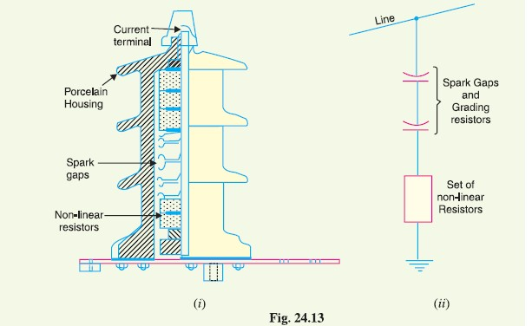

Working. Under normal conditions, the normal system voltage is insufficient to cause the breakdown
of air gap assembly. On the occurrence of an overvoltage, the breakdown of the series spark
gap takes place and the surge current is conducted to earth via the non-linear resistors. Since the
magnitude of surge current is very large, the non-linear elements will offer a very low resistance to the passage of surge. The result is that the surge will rapidly go to earth instead of being sent back over
the line. When the surge is over, the non-linear resistors assume high resistance to stop the flow of
current.
Advantages
(i) They provide very effective protection (especially for transformers and cables) against
surges.
(ii) They operate very rapidly taking less than a second.
(iii) The *impulse ratio is practically unity.
Limitations
(i) They **may fail to check the surges of very steep wave front from reaching the terminal
apparatus. This calls for additional steps to check steep-fronted waves.
(ii) Their performance is adversely affected by the entry of moisture into the enclosure. This
necessitates effective sealing of the enclosure at all times.
Applications. According to their application, the valve type arresters are classified as (i) station
type and (ii) line type. The station type arresters are generally used for the protection of important
equipment in power stations operating on voltages upto 220 kV or higher. The line type arresters are
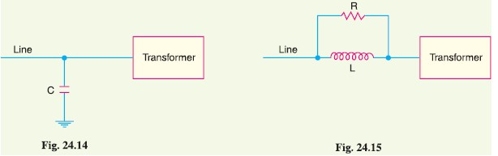
also used for stations handling voltages upto 66 kV.
Surge Absorber
The travelling waves set up on the transmission lines
by the surges may reach the terminals apparatus and
cause damage to it. The amount of damage caused not
only depends upon the amplitude of the surge but also
upon the steepness of its wave front. The steeper the
wave front of the surge, the more the damage caused
to the equipment. In order to reduce the steepness of
the wave front of a surge, we generally use surge absorber.
A surge absorber is a protective device which
reduces the steepness of wave front of a surge by absorbing
surge energy.
Although both surge diverter and surge absorber
eliminate the surge, the manner in which it is done is
different in the two devices. The surge diverter diverts
the surge to earth but the surge absorber absorbs the
surge energy. A few cases of surge absorption are discussed
below :
(i) A condenser connected between the line and earth can act as a surge absorber. Fig. 24.14
shows how a capacitor acts as surge absorber to protect the transformer winding. Since the
reactance of a condenser is inversely proportional to frequency, it will be low at high frequency
and high at low frequency. Since the surges are of high frequency, the ***capacitor acts as a short circuit and passes them directly to earth. However, for power frequency, the
reactance of the capacitor is very high and practically no current flows to the ground.
(ii) Another type of surge absorber consists of a parallel combination of choke and resistance
connected in series with the line as shown in Fig. 24.15. The choke offers high reactance to
surge frequencies (XL = 2 f L). The surges are, therefore, forced
to flow through the resistance R where they are dissipated.
(iii) Fig. 24.16 shows the another type of surge absorber. It is called
Ferranti surge absorber. It consists of an air cored inductor connected
in series with the line. The inductor is surrounded by but
insulated from an earthed metallic sheet called dissipator. This arrangement
is equivalent to a transformer with short-circuited secondary.
The inductor forms the primary whereas the dissipator forms
the short-circuited secondary. The energy of the surge is used up in the form of heat generated
in the dissipator due to transformer action. This type of surge absorber is mainly used
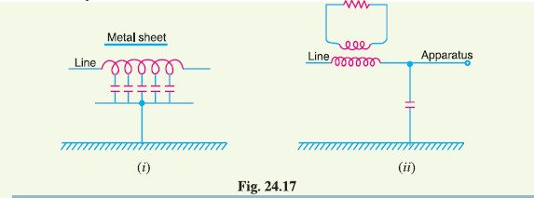
for the protection of transformers.

Fig. 24.17 (i) shows the schematic diagram of 66 kV
Ferranti surge absorber while Fig. 24.17 (ii)
shows its equivalent circuit.

